ST ANDREW’S COLLEGE POLICY DOCUMENT
Issue No.: 03 | Document Number: STAN: 0212008
Issue Date: June 2011 | Originator: Wayne Marshall
Version: 11 | Responsibility: Principal
Reason for version change: Review & Update | Dated: 4th July 2008
Authorised by: Wayne Marshall  Date: 14/08/2019 | 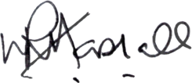  Signature

