ST ANDREW’S COLLEGE POLICY DOCUMENT
Issue No.: 01 | Document Number: STAN: 0102007
Issue Date: 22nd June 2011 | Originator: Wayne Marshall
Version: 12 | Responsibility: Principal
Reason for version change: Review & Update | Dated: 31st August 2019
Authorised by: Wayne Marshall  Date: 31st August 2019 | 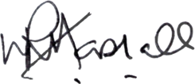  Signature

