**BEHAVIOUR POLICY 2025 - 2026**

|  |  |
| --- | --- |
| **ST ANDREW’S COLLEGE POLICY DOCUMENT** | |
| **VERSION:** | **RESPONSIBILITY: Helen Walker** |
| **REASON FOR VERSION CHANGE: Review & Update** | **TO BE REVIEWED: August 2026** |
| **AUTHORISED BY:**  **DATE:** | **SIGNATURE:** |

# **Vision and Aims**

This Behaviour Policy has been written with regard to the Behaviour in Schools: Advice for Headteachers and School Staff (DfE, September 2023), the Searching, Screening and Confiscation Guidance (DfE, July 2022), and the National Minimum Standards for Boarding Schools (DfE, September 2022).  
   
St Andrew’s College is committed to creating a safe, respectful, and inclusive environment in which all students can thrive. Good order and discipline are preconditions for a happy and successful learning and boarding community.  
   
Our aims are to:  
 - Foster habits of self-discipline, tolerance, and cooperation.  
 - Develop intrinsic motivation – students value achievement for its own sake and for the good of the community, not only for external rewards or fear of sanction.  
 - Promote Behaviour for Learning, where conduct enables individuals and groups to make academic and personal progress.  
 - Support students in taking responsibility for their choices, preparing them for adult life.  
 - Ensure all members of the community feel safe, respected, and supported.

# **Expectations**

We expect all members of the College community to:  
 - Show courtesy, kindness, and respect towards others regardless of background or protected characteristic.  
 - Respect physical boundaries and personal space.  
 - Consider the feelings of others and act in good faith.  
 - Be honest and trustworthy.  
 - Respect belongings and College property.  
 - Take responsibility for choices and accept accountability.  
 - Work to repair relationships where harm has been caused.  
   
Students are expected to:  
 - Follow the College rules (as outlined in the Student Handbook).  
 - Follow instructions from all staff, teaching and non-teaching.  
 - Behave responsibly at all times – in classrooms, in boarding, online, on trips, and when representing the College off-site.

# **Acceptable and Unacceptable Behaviour**

Acceptable behaviour is defined as conduct that promotes courtesy, cooperation, and respect, enabling effective learning and harmonious community life.  
   
Unacceptable behaviour includes but is not limited to:  
 - Defiance or ignoring staff instructions.  
 - Rudeness, ridicule, or verbal abuse.  
 - Harassment, bullying, or discrimination (including racist, sexist, homophobic, transphobic, or faith-based abuse).  
 - Physical aggression, intimidation, or unwanted physical contact.  
 - Inappropriate displays of affection.  
 - Theft, vandalism, or littering.  
 - Extremist language or behaviour.  
 - Disruption of learning.  
 - Misuse of digital devices, including cyberbullying, academic dishonesty (e.g. misuse of AI tools), or online harassment.

Or inciting any of the above

# **Boarding Expectations**

In addition to the above, boarders are expected to:  
 - Return punctually to Halls.  
 - Observe curfews and signing-in procedures.  
 - Refrain from smoking, vaping, or alcohol use on College premises.

# **Communicating Behaviour Standards**

Students: Induction sessions, Student Handbook, assemblies, form time, tutor meetings, PSHE lessons, pastoral support, and boarding meetings.  
 Parents/Carers/Agents: Handbooks, regular communications, letters, and parent meetings.  
 Staff: Training programmes, meetings, and updates.  
   
Re-induction following serious or repeated misbehaviour may involve reintegration meetings, behaviour contracts, or reports to Tutors/Senior Staff.

# **Sanctions**

Sanctions are proportionate, consistent, and take account of students’ age, SEND, and protected characteristics. They will never involve corporal punishment, deprivation of food/drink, or restriction of communication with parents/agents.

Low level unwanted behaviours will in the first instance be dealt with by a member of staff, through conversation and reminders of rules and expectations. Further instances of unwanted behaviour may result in sanctions.

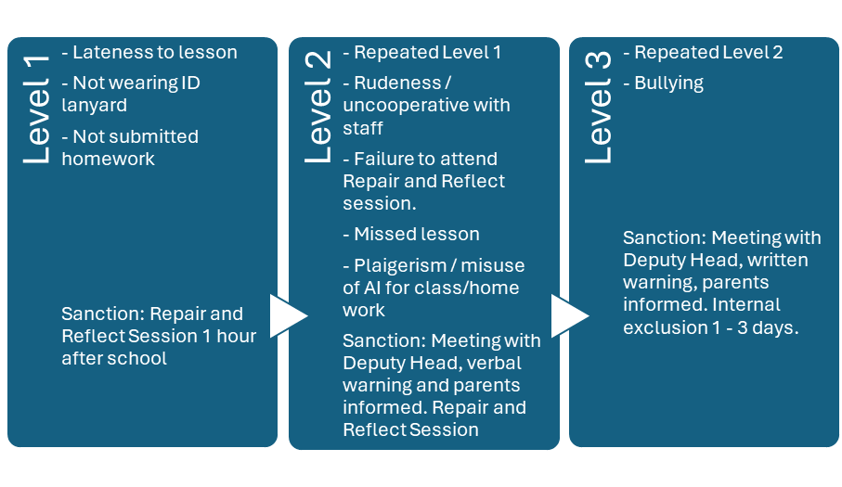

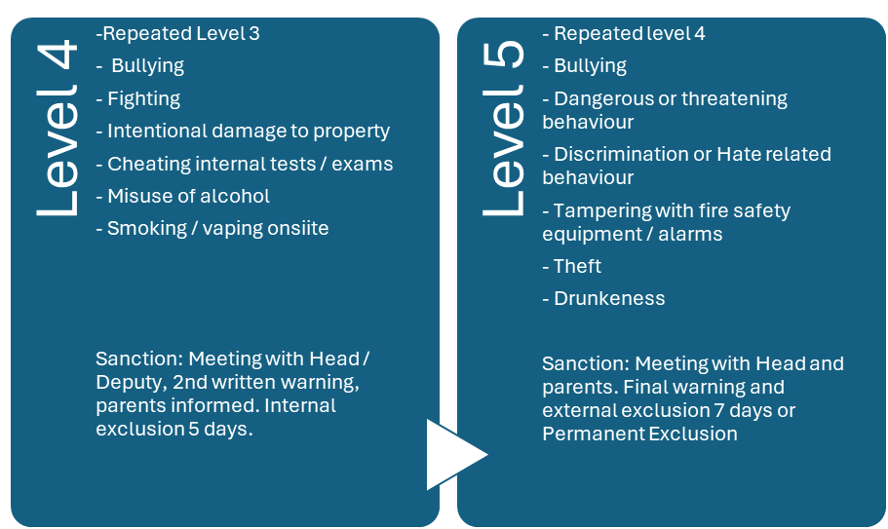

Serious breaches (likely to lead to exclusion): violence, sexual abuse/assault, possession/supply of drugs, alcohol, vapes, offensive weapons, bullying, persistent disruption, conduct bringing College into disrepute. The behaviours listed in the flowchart and above are not exhaustive but are representative of the types of behaviours and likely outcomes.

# **Searching, Screening, and Confiscation**

In line with DfE guidance (2022):  
 - The Head and authorised staff have the right to search students for prohibited items (including weapons, drugs, stolen goods, alcohol, vapes, fireworks, pornography, and items used to cause harm or disruption).  
 - Confiscated items will be retained, destroyed, or handed to the police as appropriate.  
 - Parents/agents will be informed where appropriate.

**Rewards**

The College strongly values positive reinforcement. Rewards may include:  
 - iSAMS entries for positive behaviour and effort.  
 - Verbal praise in lessons and assemblies.  
 - Certificates and commendations including Student or Boarder of the Week.  
 - Letters, calls, or emails home to parents/agents.  
 - Leadership roles and responsibilities in boarding or College life.  
 - Privileges in boarding (e.g. later curfew, choice of activities).  
 - House points  
 - Termly awards ceremonies to celebrate achievement.  
   
We aim to ensure that praise and recognition significantly outweigh sanctions, creating a culture where positive behaviour is the norm.

# **SEND and Reasonable Adjustments**

Students with SEND are held to high expectations. Reasonable adjustments may be made in line with individual needs. SENCO, pastoral staff, and tutors work as a team to assess, plan, implement, and review support.

# **Use of Reasonable Force**

Corporal punishment is illegal and not permitted. Reasonable force may be used only to prevent harm, damage to property, or serious disruption. All incidents must be logged, reported to the Head (or DSL in their absence), and reviewed. Parents/agents will be informed.

# **Governance and Oversight**

The Governing Body monitors the behaviour log termly. Behaviour is also reviewed by the Dukes Director of Compliance and Safeguarding Governor. Appeals against permanent exclusion follow the College Complaints Procedure (Stage 3).